**Endeavour tips**

* To check for changes in the code do **‘F %’**

**wORKING WITH pr**

1. Create a CR(Change Request) in Remedy.
2. Lets say ticket no is **CRQ001000004961** Then Package no is last 6 digits

Package no=**Z004961**

CCID is last 7 digits of the ticket no

CCID=**#0004961**

1. Now create a package in Endevour
2. Select the components into the package by using # key

create a package in Endevour

Select the region from where u want to create a package.

Lets say the requirement is to decomisssion certain components(JCL,Cobol etc..)

Lets select 62(Production).

Then go to

4( PACKAGE - Perform foreground package processing) 🡪

**Creation of Lpackage: L004961**

Generally Lpackage is created for addition of one time jobs and normal jobs that needs to moved step by step until production.

To create a L package select the region say unit3 then goto

**4 PACKAGE** - Perform foreground package processing)

Then enter **package id** and select

**2 CREATE/MODIFY** - Create or Modify Package

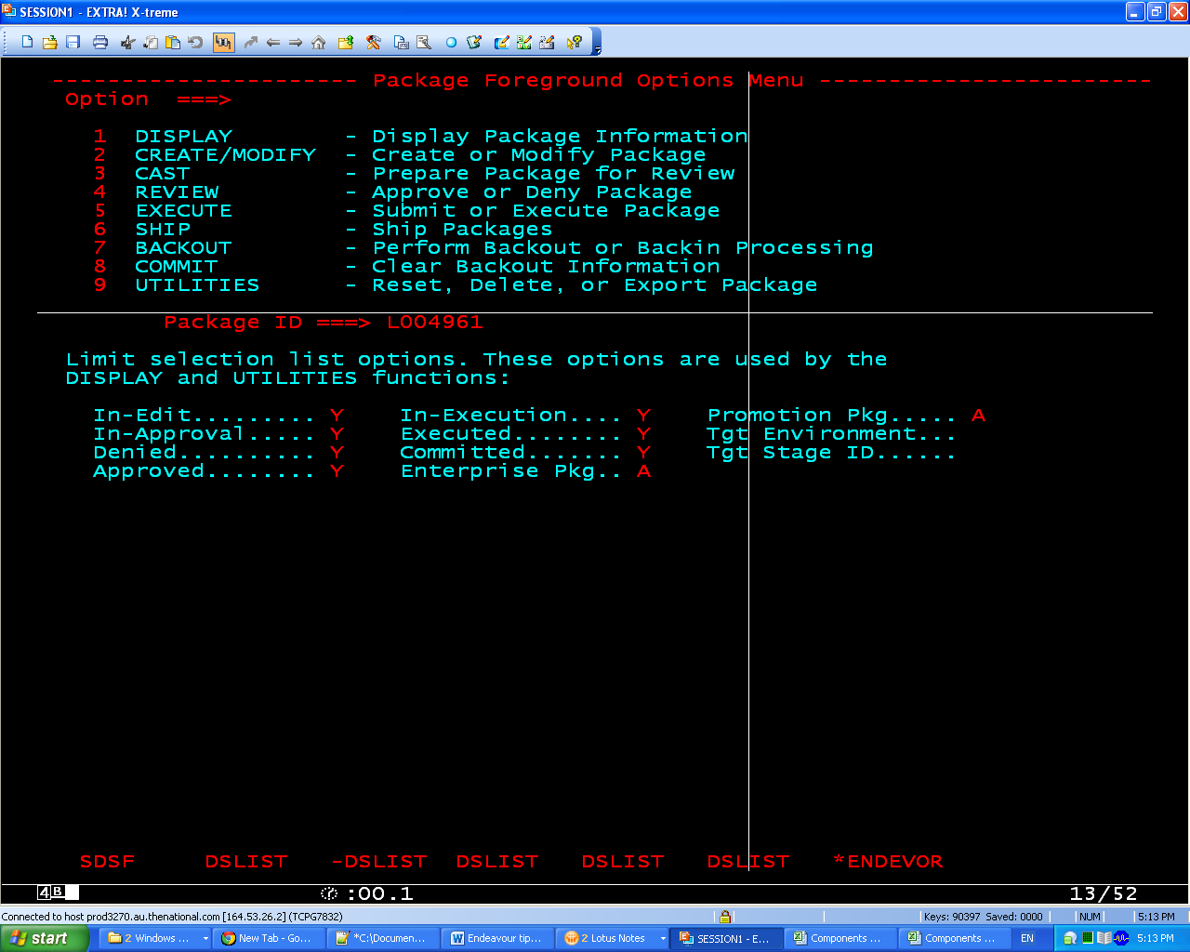

**Retrieve elements and signout**

**or CHECKout**

**En;3(Batch)**

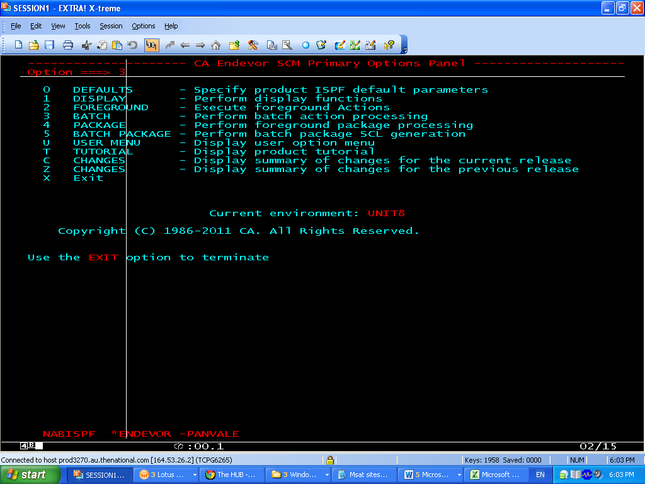

**1(BUILD SCL)**

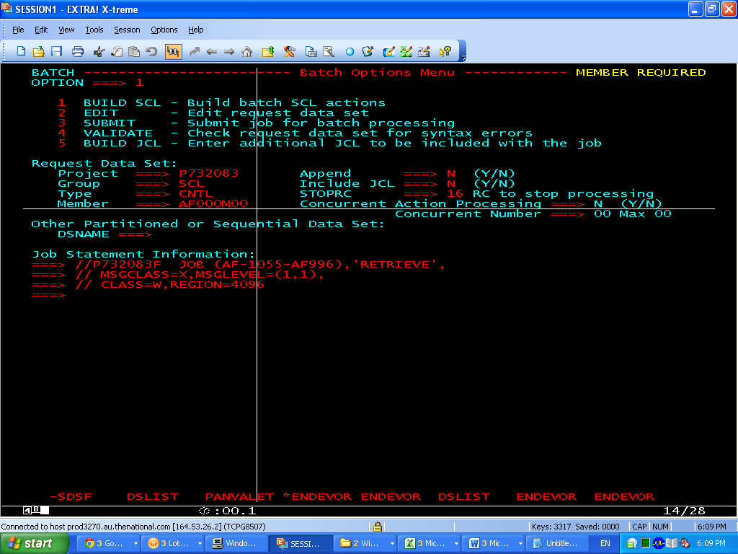

//P732083F JOB (AF-1055-AF996),'RETRIEVE',

// MSGCLASS=X,MSGLEVEL=(1,1),

// CLASS=W,REGION=4096

**3(RETRIEVE)**

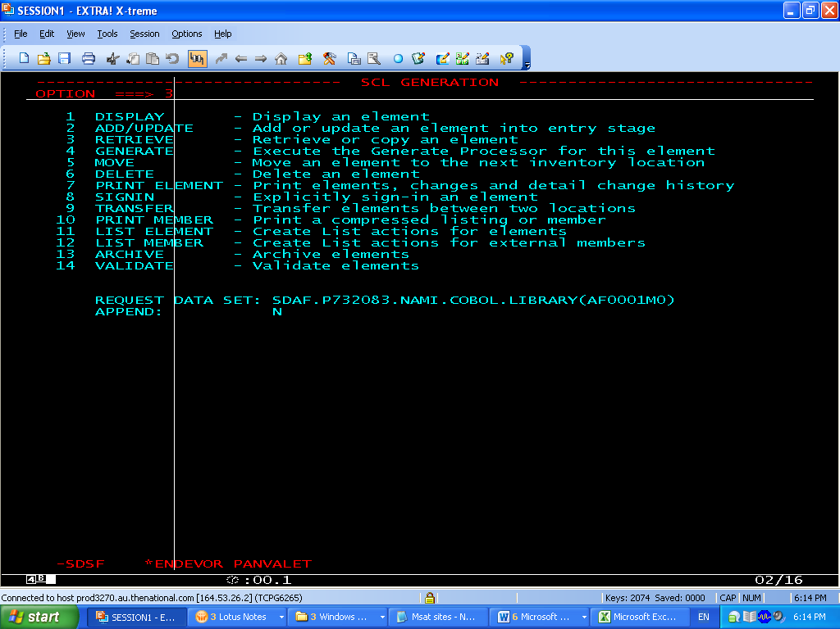

**GIVE**

**SIGNOUT ELEMENT ===> N (if you don’t know ccid)**

**DATA SET NAME ===> 'SDAF.P732083.NAMI.PANV.COBOL.LIBRARY'**

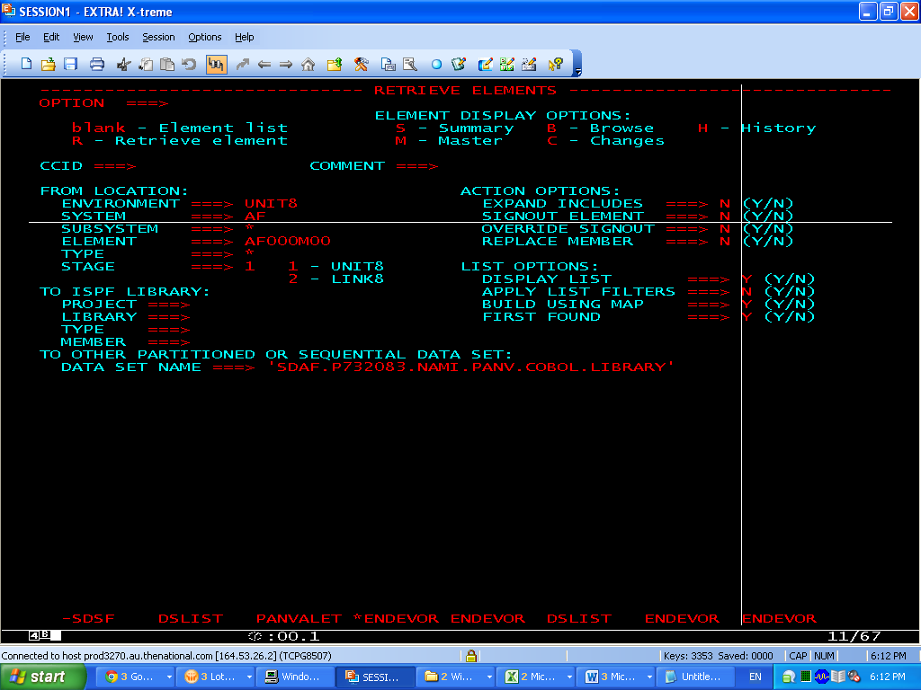

pRESS f3 TWICE AND finally submit the jcl by selecting **3(SUBMIT)**

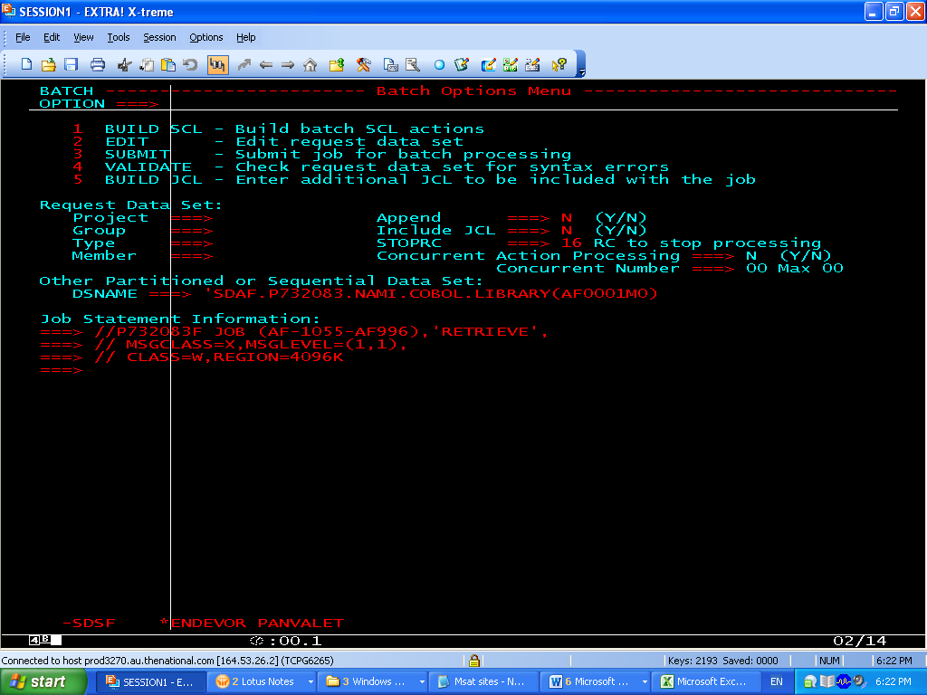

**ADDING Elements to Endeavor Unit3**

Go to **START en 5; -> 3 BATCH -> 1(Build SCL)**

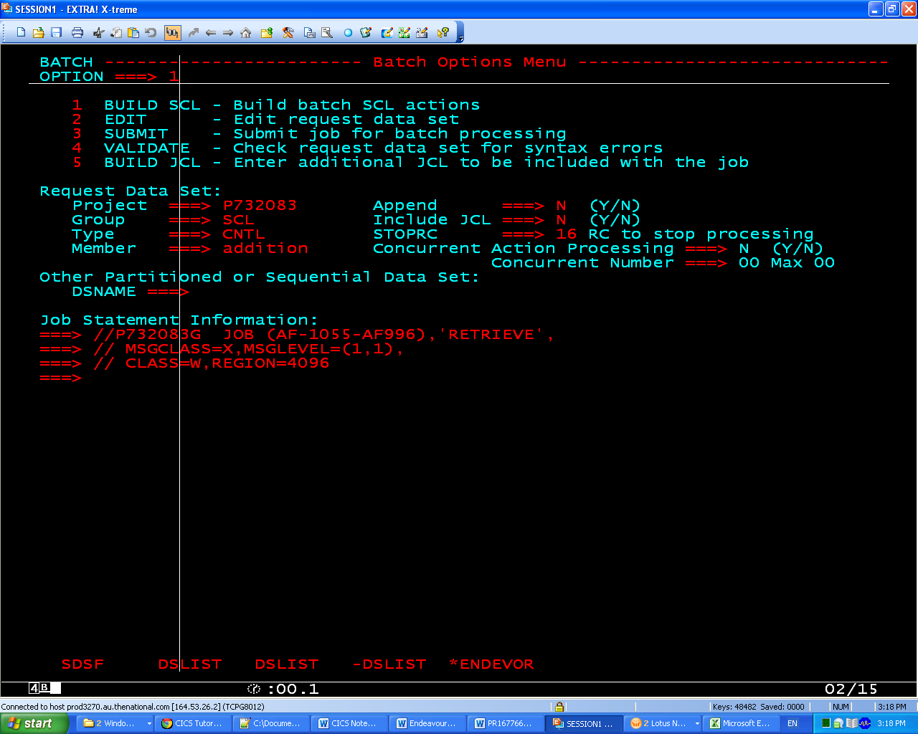

2 ADD/UPDATE

